AN INTRODUCTION TO WAR:

REASONS FOR WORLD WAR I
There are many reasons for the start of World War I. Students will examine three of the reasons:
1. Nationalism is a great love for your country. The word comes from the word "nation", which means the same as "country." Many people in Europe showed extreme nationalism. If you believe that your country is the best, how do you show your belief?. For some people, it meant fighting in a war to see who was number one.
2. Alliances are agreements or “deals” between countries, to back each other up in case of trouble. The word “alliance” comes from the word “ally” or friend. In today’s society, a young person may join a street gang for protection against people in another gang. Before the start of World War I, countries joined alliances for protection.
3. An arms race is a competition between two or more countries to see who can produce the most “arms”, or weapons. Before World War I, the country of the United Kingdom (also known as Britain) and the country of Germany were involved in an arms race.
The three factors mentioned above, nationalism, alliances, and the arms race, led to great tension between the countries of Europe prior to 1914. Many countries were ready for war, and in June 1914, something happened that set off the spark which would start the Great War.
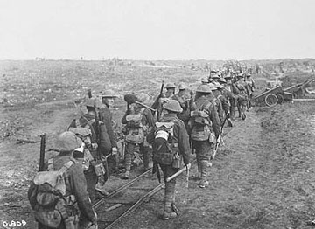
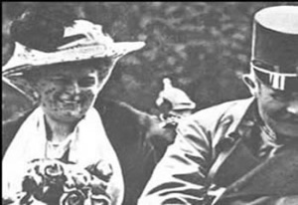
In history, we often look at the causes of big events; today, students will look at an event that led to the death of about 10 million human beings. This event is World War I - a war that lasted from 1914 to 1918. Most of the fighting in this war took place in Europe, but countries from all over the world took part and, therefore, it is called a “world war.” For example, Canada, the United States, and Australia are not European countries, but they all took part in the war. You will look at the reasons why later in this activity.

TERRORISM AND WAR:
Archduke Franz Ferdinand
On June 28, 1914, in the city of Sarajevo, Bosnia, a terrorist killed the man who was to be the next king of Austria-Hungary (Franz Ferdinand). The terrorist was Gavrilo Princip and he belonged to a terrorist group called the “Black Hand”.

TERRORISM AND WAR: The "Showdown"
The "Black Hand" was a group based in the country of Serbia and they wanted to take Bosnia away from Austria-Hungary. In order to threaten Austria-Hungary, the "Black Hand" killed Franz Ferdinand and his wife.
Next, Austria-Hungary issued an ultimatum to Serbia. An ultimatum is a statement of serious consequences if certain conditions are not met. For example, a teacher may say, “Be quiet, or get out of this class!” In 1914, Austria-Hungary’s ultimatum to Serbia was: “Hand over the Black Hand, or we attack!”
In the “showdown,” Serbia was backed by its friend Russia. Austria-Hungary was backed by its ally Germany. Serbia stood its ground. To back up Serbia, Russia moved troops to the borders of Germany. Germany told Russia to remove the troops from the border. Russia refused and then Germany declared war on Russia.

TERRORISM AND WAR:  The Outbreak Of War  Germany knew that Russia was allied with France, and therefore Germany decided to attack France. The German attack went through the neutral country of Belgium. A neutral country is a country that is on neither side in an argument. When Germany went through the neutral country of Belgium, Britain entered the war against Germany. | 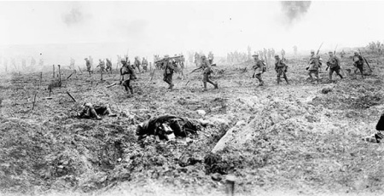  Canadian troops advance across No-Man's Land  Library and Archives Canada
In 1914, Canada was a colony belonging to Britain. A colony is a country that is controlled by another country. Therefore, Canada, like Australia (another British colony), quickly volunteered to help the “mother country” of England (a part of Britain). At this time, a large percentage of Canadians had connections to England - by birth or family - and the decision to help England was a popular one.

