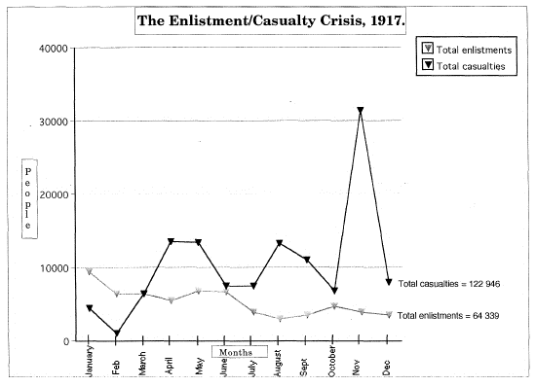
THE CONSCRIPTION CRISIS
Look at the following chart. This chart represents the number of soldiers who enlisted in the war, and the number of soldiers who died each month. What do you notice about these numbers? Why are these numbers a problem for the Canadian government? What might be some possible solutions?
The Canadian Government needed to solve this decline in enlistment. Conscription seemed to be the only solution. Conscription means that men between the ages of 18 and 45 are legally required to sign up and fight the war.
The Background
- Conscription means to sign people up for mandatory service.
- The reality of the horrors of the trenches changed some attitudes and people stopped volunteering.
- Most of the available Canadian men had already signed up.
- The volunteer system was not recruiting enough soldiers to replace the losses
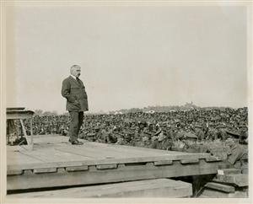  August 11, 1918 - Did Borden know the consequences of his actions? | - May 1917, Borden visited Vimy Ridge; he was moved by the hardship and sacrifice endured by the troops.  - Later that month when Borden returned to Canada he announced that “all citizens are liable for the defence of their country and I conceive that the battle for Canadian liberty and autonomy is being fought on the plains of France and Belgium.”  - Many English Canadians approved of the government's actions as a necessary step but also thought it would force French Canada to increase low enlistment rate.  - The Military Service Act became law on August 28, 1917 making enlistment mandatory. Canada became a divided nation. Emotions were running high.

A DIFFERENCE OF OPINION
Pro-Conscription (Yes we should do it)
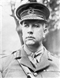
Sir Arthur Currie
“The men who are here now are committed until peace is declared. If no others are sent to help them they can look forward to nothing else but to be killed or permanently maimed.”
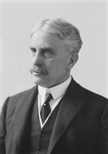
Prime Minister Robert Borden
“I believe the time has come when the authority of the state should be invoked to provide reinforcements necessary to sustain the gallant men at the front who have held the line for months, who have proved themselves more than a match for the best troops that the enemy could send against them, and who are fighting in France and Belgium that Canada may live in the future...Is there not a call to us from those who have passed beyond the shadow into the light of perfect day, from those who have fallen in France and in Belgium, from those who have died that Canada may live -- is there not a call to us that their sacrifice shall not be in vain?”
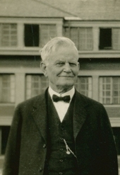
Rev. S.D. Chown
“..it is as clear as day that if we defeat conscription we cannot possibly get the last available man and fulfill our promise to Great Britain…it [conscription] is the fairest, most expeditious and least expensive method of raising an army in this country. ..it is the most moral and profoundly religious method of doing our national duty.”

Anti-Conscription (No, we shouldn’t do it)
Henri Bourassa
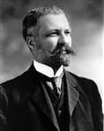
“Weigh my words: for French Canadians, the advent of conscription would trigger a process that would soon transform what is now perhaps the most peaceful and most orderly people in the Americas into a revolutionary people. Once unleashed, this revolutionary spirit would rage not only against the military regime, but everywhere: in factories, in agriculture, in every area of industry, society and politics.”
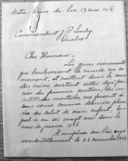
Madame Paul J. Cloutier, a widow with eight children
Without the help of her eldest boy, who had just turned 20, she could not support the family. She ran a hotel and had a small farm. “If my sole support is taken away, which would certainly contribute to kill me, what would become of my other children in the difficult circumstances we are in?”

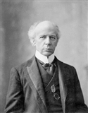
Wilfred Laurier
"Some people have accused the French Canadian race, of which I am a member, of being cowards and disloyal to Canada. That is not true. Over 16 000 French Canadians have already enlisted in the armed forces and have gone over to Europe to fight. French Canadians do not have a large amount of loyalty to France, one of the countries fighting on our side in the war.
…they have little enthusiasm for helping France today. The loyalty of French Canadians is to Canada - a country in which they have lived for over 300 years. French Canadians will approve conscription to defend Canada, but not to defend a country 3 000 kilometres away.”

What actions did the Government take?
- Borden called an election for December 1917 – the main issue was conscription.
- Prime Minister Borden took the right to vote away from immigrants from enemy countries who arrived in Canada after 1902 (30 000) and from conscientious objectors who would probably be against conscription.
- Borden gave the vote to soldiers overseas; most were for the war effort. | 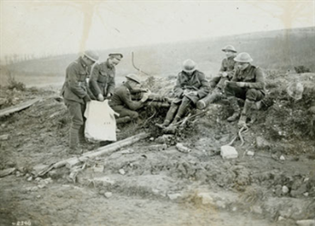  Voting for a federal election on a battlefield

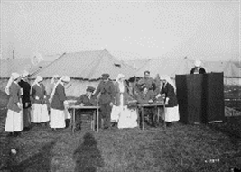  Was their sacrifice worth it? | - Wives, mothers, and sisters of absent soldiers were given the right to vote including Canadian nurses in France for the first time in a federal election.
- Borden also promised farmers that their sons would not have to go to war; this was a lie.
- The Liberal Party split in two because Quebec Liberal Members of Parliament were opposed to conscription but Liberal Members outside of Quebec were for it.
- Borden formed an alliance (a “union”) with many Liberals (who were for conscription) in order to get votes to stay in power.
The End Result
- The “Union Government” won the election of December 1917.
- 108 000 men of 620 000 who served in the CEF were conscripts.
- 48 000 went overseas and by November 1918, only 24 000 ever made it to the front lines.
- Conscription probably had no major impact on the outcome of the war, but it left deep wounds in Quebec that would take decades to heal. Riots in Quebec City, where up to 93% of eligible men asked to be excused from duty, killed 4 people, including a young boy.

