The Beginnings of World War II
Desperate times called for desperate measures. The Great Depression left many feeling hopeless, frustrated, and demanding change. Around the world, people wanted to believe that there was a way out of this crisis, if only someone could lead them. Desperation led populations to follow more radical leaders proposing big changes. By the mid-1930s, one in four Canadians were unemployed. What was there to lose at this point?
Worried about a lack of jobs and instability, the Canadian government took drastic measures. Not only did it restrict immigration, as written in this Government order from 1931, but between 1930-1935 approximately 30 000 new immigrants were deported back to their home countries, accused of being Communists and causing labour problems.

The Common Factor: Totalitarianism
As the Depression dragged through the 1930s, new forms of government began to appear in countries around the world. Although they were very different from each other, they were all totalitarian governments. Totalitarianism means that government has complete control of all aspects of a nation: politics, the military, the economy, society and culture.
These states were nationalistic and used symbols such as flags, salutes, rallies, and uniforms to create a unified identity for the population. Citizens basically gave up their individual rights for the “good of the nation” resulting in strict laws, secret police, strong militaries, censorship (opposing literature and ideas), propaganda (media – radio, newspapers, posters), and total conformity among people. Those who didn't follow the rules faced persecution that included torture, imprisonment or death.
Communism, such as the system in the USSR, was characterized by:  - A revolutionary idea of a political, economic and social system of equality that creates a “classless society”; there are no rich people, there are no poor.  - A single party of people governed on behalf of the population.  - State ownership and control of the means of production (no private ownership).  - Everything that is produced is distributed by need to the people. | 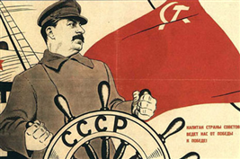  Josef Stalin, leader of the Soviet Union, steering the ship during the Depression.

Fascism in Germany and Italy was characterized by:  - Intense nationalism and elitism (promotes the strong and wealthy).  - A charismatic, and often beloved, dictator who controls all decisions of the government.  - The interests of the state were more important than individual rights.  - Maintaining a class system and private ownership (rich get richer; the people own and operate businesses). | 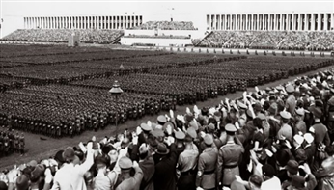  Hitler held massive rallies attended by loyal Germans.

Communist and Fascist movements were also gaining popularity in Canada. The Nazi Party in Canada was headed by Montreal journalist Adrien Arcand and encouraged the establishment of "swastika clubs" across Canada.  “I swear to execute without discussion the orders of il Duce [the Italian Dictator Benito Mussolini] and to serve with all my strength and if necessary with my blood the cause of the Fascist Revolution.”  The oath that appeared on fascist membership cards from “The Organization and Activities of the Italian Fascist Party in Canada,” Library and Archives Canada | 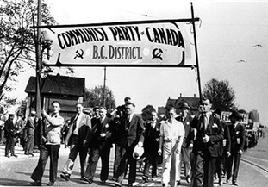  Would you have joined one of these parties during the Depression? Why or why not?  Why do you think there were Canadians joining radical political parties like the Communist Party of Canada or the Canadian Union of Fascists?
Alliances were being formed, dictatorships were rising, and tensions were growing in Europe as a result of the new borders outlined by the Treaty of Versailles.

First Impressions

Prime Minister MacKenzie King wrote in his diary after meeting, "My sizing up of the man as I sat and talked with him was that he is really one who truly loves his fellow-men, and his country, and would make any sacrifice for their good." (Diary, June 29, 1937) Hitler appeared to be "a man of deep sincerity and a genuine patriot." (Diary, June 29, 1937) King left Germany with an autographed and framed photo of Hitler given to him by Hitler himself after a meeting. King was hopeful that war could be avoided. | 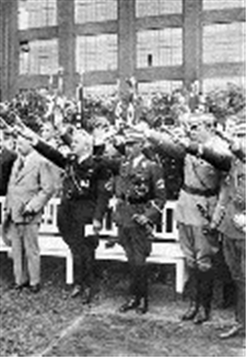  Prime Minister MacKenzie King visited Hitler in 1937
King also met with Germany's foreign minister, Baron von Neurath. King wrote, "He said to me that I would have loathed living in Berlin with the Jews, and the way in which they had increased their numbers in the city ... He said there was no pleasure in going to a theatre which was filled with them .... They were getting control of all the business, the finance .... It was necessary to get them out to have the German people really control their own City and affairs." (Diary, June 30, 1937)
Were these ideas unique to Germany?

Fascism and Anti-Semitism in Canada
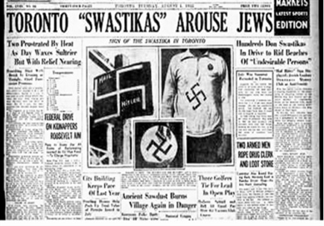d | Although we would like to think that anti-Semitism was only a belief held by Nazis, it was common across Canada. In Toronto, anti-Semitic signs were placed on lawns, shirts were sold with the swastika symbol, and slurs were hurdled at Jews living in some communities to make them feel unwanted.

In Winnipeg signs were placed in public areas forbidding Jews from sharing the same space. Many political parties clearly stated their dislike for Jews including Adrien Arcand the leader of the National Unity Party. His newspaper the Canadian Nationalist spread hatred of foreigners and preached the idea that some races were better than others. The ideas of dictators from around the world were popping up here in Canada creating conflict. | 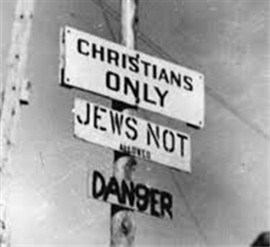How do these ideas spread?

Causes of World War II: HALT
- Hitler and the Rise of Dictators
- Appeasement
- League of Nations
- Treaty of Versailles
- Reasons why Hitler rose to power
- Hitler was a great speaker, with the power to make people support him.
- The moderate political parties would not work together, although together they had more support than the Nazis.
- The depression of 1929 created poverty and unemployment, which made people angry with the Weimar government. People lost confidence in the democratic system and turned towards the extremist political parties such as the Communists and Nazis during the depression.
- The Nazi storm troopers attacked Hitler's opponents.
- Goebbels' propaganda campaign was very effective and it won support for the Nazis. The Nazis targeted specific groups of society with different slogans and policies to win their support.
- Hitler was given power in a seedy political deal by Hindenburg and Papen who foolishly thought they could control him.
- German people were still angry about the Treaty of Versailles and supported Hitler because he promised to overturn it.
- Industrialists gave Hitler money and support.

- Appeasement means to negotiate and give in to make someone happy in order to prevent further conflict. In the case of Germany during the 1930s, many countries such as Great Britain and Canada, believed “appeasing” Hitler and his desire to reclaim some of the German Empire lost during World War I would make up for the harsh punishment outlined in the Treaty of Versailles and ultimately maintain peace.

- The League of Nations was created at the end of World War I to prevent future conflicts and war. There are several reasons why it failed. First, the most influential country in the world, The United States, never joined. Second, the League had no way to enforce international laws except by limiting trade and financial support (called economic sanctions) to countries that didn't follow the rules. Lastly, in spite of economic sanctions, Japan, Italy and Germany all began to rebuild their militaries and invade other countries, and there was little the League could do about it.

- Recall the terms of the Treaty of Versailles at the end of World War I. The clause that laid the foundation for so much bitterness among the German people was the War Guilt Clause. It gave Hitler a purpose to rally the citizens and start using their hate to engage in revenge. Many argue that the Treaty of Versailles was directly connected to the start of World War II. Some even predicted that this would spark another war back in 1919.

World War Two began in September 1939 after Germany's invasion of Poland. This was the final straw. It was clear that Hitler could not be appeased. Great Britain and France could no longer sit by hoping for a resolution that would ensure no war. Although the outbreak of war was triggered by Germany's invasion of Poland, the causes of the war are more complex. It is important to look at how causes are interconnected. Causes of an event often work together making them more powerful.
The following descriptors describe the connection between the causes of the war.
    - Paying reparations left Germany in debt.
    - Desperation of many forced them to seek new leaders.
    - Countries cannot afford another war.
    - Encourages the rise of dictators because they realize no one will stop them.
    - No one can afford to send resources to support the League's decisions.
    - Taking full blame leaves Germany wanting revenge.
    - Some countries felt that the Treaty punished Germany too harshly.
    - With high rates of unemployment, preventing war would be in the best interests of citizens.
    - The loss of loved ones, the destruction of land, living through post-war was still harsh and fresh in the minds of many.

