Unit 5: Similar Triangles

Similarity versus Congruence
Consider the triangle below:
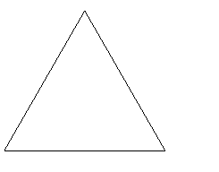
or if it is translated,
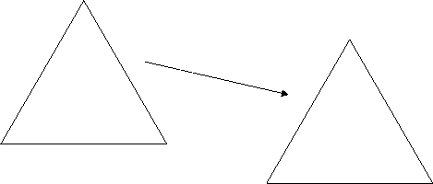
The triangles are in fact the same. That means the triangles are congruent.
If it is rotated,
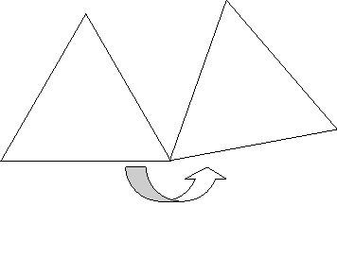
In mathematics, when things are said to be congruent, all corresponding aspects (length, angles, etc.) are equal. Triangles that are congruent to each other have corresponding angles and sides that are all equal to each other. In the diagram below, triangle ABC is congruent to triangle EDF.
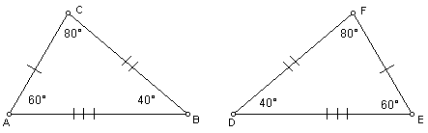
The conditions for triangles to be congruent are:
- three sides of one triangle equal to three sides of a second triangle OR
- two sides and one contained angle of one triangle equal to two sides and one contained angle of a second triangle OR
- two angles and the contained side of one triangle equal to two angles and the contained side of a second triangle

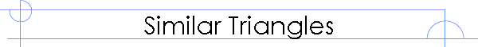
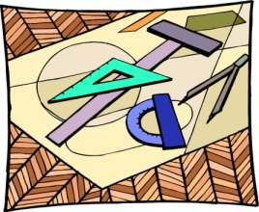
When a house is built, architectural drawings are produced first. These drawings are used to help build the house. Compared to the actual house, these drawings are similar, but not equal in size to the house. They are proportional representations of what the house will look like.
- It is the same with similar triangles.
A ratio is a comparison of values. It can be written as 2:3 or . When working with similar triangles in the investigations, the fraction notation will be used.
If two shapes are similar, one is an enlargement of the other. This means that the two shapes will have the same angles and their sides will be in the same proportion (e.g. the sides of one triangle will all be 3 times the sides of the other etc.).
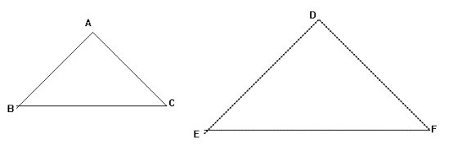
angle A = angle D
angle B = angle E
angle C = angle F
$\frac{AB}{DE}=\frac{BC}{EF}=\frac{AC}{DF}=\frac{perimeter of ∆ABC}{perimeter of ∆DEF}$
Two triangles are similar if:
- 3 angles of 1 triangle are the same as 3 angles of another triangle
- 3 pairs of corresponding sides are in the same ratio
- an angle of 1 triangle is the same as the angle of another triangle and the sides containing these angles are in the same ratio.
Example:
In the above diagram, the triangles are similar. EF = 6cm and BC = 2cm . What is the length of DE if AB is 3cm?
EF = 3BC, so DE = 3AB = 9cm.

