A history of residential schools in Canada
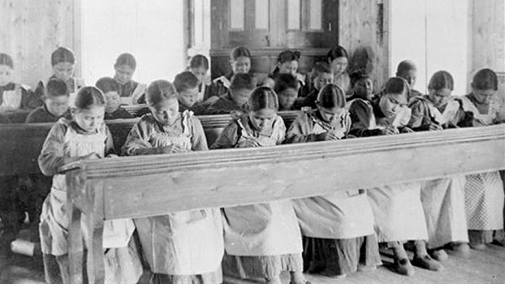
It is estimated that about 150,000 aboriginal, Inuit and Métis children were removed from their communities and forced to attend residential schools. (Library and Archives Canada/PA-042133)

What is a residential school?
In the 19th century, the Canadian government believed it was responsible for educating and caring for aboriginal people in Canada. It thought their best chance for success was to learn English and adopt Christianity and Canadian customs. Ideally, they would pass their adopted lifestyle on to their children, and native traditions would diminish, or be completely abolished in a few generations.
The Canadian government developed a policy called "aggressive assimilation" to be taught at church-run, government-funded industrial schools, later called residential schools. The government felt children were easier to mold than adults, and the concept of a boarding school was the best way to prepare them for life in mainstream society.
Residential schools were federally run, under the Department of Indian Affairs. Attendance was mandatory. Agents were employed by the government to ensure all native children attended.

How many residential schools and students were there?
Initially, about 1,100 students attended 69 schools across the country. In 1931, at the peak of the residential school system, there were about 80 schools operating in Canada. There were a total of about 130 schools in every territory and province except Newfoundland, Prince Edward Island and New Brunswick from the earliest in the 19th century to the last, which closed in 1996.
In all, about 150,000 First Nation, Inuit and Métis children were removed from their communities and forced to attend the schools.

What went wrong?
Residential schools were established with the assumption that aboriginal culture was unable to adapt to a rapidly modernizing society. It was believed that native children could be successful if they assimilated into mainstream Canadian society by adopting Christianity and speaking English or French. Students were discouraged from speaking their first language or practising native traditions. If they were caught, they would experience severe punishment.
Throughout the years, students lived in substandard conditions and endured physical and emotional abuse. There have also been convictions of sexual abuse. Students at residential schools rarely had opportunities to see examples of normal family life. Most were in school 10 months a year, away from their parents; some stayed all year round. All correspondence from the children was written in English, which many parents couldn't read. Brothers and sisters at the same school rarely saw each other, as all activities were segregated by gender.
According to documents obtained by the CBC, some schools carried out nutritional experiments on malnourished students in the 1940s and '50s with the federal government's knowledge.
When students returned to the reserve, they often found they didn't belong. They didn't have the skills to help their parents, and became ashamed of their native heritage. The skills taught at the schools were generally substandard; many found it hard to function in an urban setting. The aims of assimilation meant devastation for those who were subjected to years of abuse.

When did the calls for victim compensation begin?
In 1990, Phil Fontaine, then-leader of the Association of Manitoba Chiefs, called for the churches involved to acknowledge the physical, emotional, and sexual abuse endured by students at the schools. A year later, the government convened a Royal Commission on Aboriginal Peoples. Many people told the commission about their residential school experiences, and the commission's 1996 report recommended a separate public inquiry into residential schools. That recommendation was never followed.
Over the years, the government worked with the Anglican, Catholic, United and Presbyterian churches, which ran residential schools, to design a plan to compensate the former students.
In 2007, two years after it was first announced, the federal government formalized a $1.9-billion compensation package for those who were forced to attend residential schools.

Under the federal compensation package, what have former students received?
Compensation called Common Experience Payments was made available to residential schools students who were alive as of May 30, 2005. Former residential school students are eligible for $10,000 for the first year or part of a year they attended school, plus $3,000 for each subsequent year.
Any money remaining from the $1.9-billion package will be given to foundations that support learning needs of aboriginal students.
As of Sept. 30, 2013, $1.6 billion had been paid, representing 105,548 cases.
Acceptance of the Common Experience Payment releases the government and churches from all further liability relating to the residential school experience, except in cases of sexual abuse and serious incidents of physical abuse.

What has happened in cases of alleged sexual or serious physical abuse?
An Independent Assessment Process, or IAP, was set up to address sexual abuse cases and serious incidents of physical abuse. A former student who accepts the Common Experience Payment can pursue a further claim for sexual or serious physical abuse.

Is there more to the package than compensating the victims?
The government funded a Commemoration initiative, which consisted of events, projects and memorials on a national and community level.
The Aboriginal Healing Foundation was established in 1998 with a $350-million grant from Indian and Northern Affairs Canada to help former students who were physically or sexually abused, but federal funding ended in 2010.
The settlement also promised a Truth and Reconciliation Commission to examine the legacy of the residential schools.
Prime Minister Stephen Harper delivered an official apology to residential school students in Parliament on June 11, 2008.

Who else has apologized for the abuse?
Many churches implicated in the abuse apologized in the 1990s. Archbishop Michael Peers offered an apology on behalf of the Anglican Church of Canada in 1993, stating "I am sorry, more than I can say, that we were part of a system which took you and your children from home and family."
Four leaders of the Presbyterian Church signed a statement of apology in 1994. "It is with deep humility and in great sorrow that we come before God and our aboriginal brothers and sisters with our confession," it said.
The United Church of Canada formally apologized to Canada's First Nations people in 1986, and offered its second apology in 1998 for the abuse that happened at residential schools.
"To those individuals who were physically, sexually, and mentally abused as students of the Indian Residential Schools in which the United Church of Canada was involved, I offer you our most sincere apology," the statement by the church's General Council Executive said.
Though the Catholic church oversaw three-quarters of Canadian residential schools, it was the last church to have one of its leaders officially address the abuse.
'I am sorry, more than I can say, that we were part of a system which took you and your children from home and family.'—Archbishop Michael Peers, Anglican Church of Canada
On April 29, 2009, Pope Benedict XVI expressed his "sorrow" to a delegation from Canada's Assembly of First Nations for the abuse and "deplorable" treatment that aboriginal students suffered at Roman Catholic Church-run residential schools.
At the time, then Assembly of First Nations Leader Phil Fontaine said it wasn't an "official apology," but added that he hoped the statement would "close the book" on the issue of apologies for residential school survivors.

What is the mandate of the Truth and Reconciliation Commission?
Established on June 1, 2008, the goals of the TRC include documenting and promoting the extent and impact of residential school experiences; providing a safe setting for former students to share their stories; and producing a report to the federal government on the legacy of the residential school system.
The commission has held events in several Canadian cities to publicly address the experiences of First Nations, Metis, and Inuit children in residential schools across the country.
One of the accomplishments of the TRC was gaining access to more of the 3.5 million documents held by the federal government related to residential schools. First Nations leaders and activists say these files could build a stronger case for genocide in Canada.
The TRC's mandate was supposed to end in 2014, but in Nov. 2013, Bernard Valcourt, the minister of Aboriginal Affairs and Northern Development, announced that the TRC would be given until June 30, 2015, to complete its mandate.
Source: http://www.cbc.ca/news/canada/a-history-of-residential-schools-in-canada-1.702280

