Were the best decisions for all Canadians made?
In the 1980s, Canada started to engage in more international trade agreements as part of the Globalization movement.
In 1985, Prime Minister Brian Mulroney began to negotiate with the United States to create a free trade agreement.  Free trade means that the involved countries no longer pay tariffs and other barriers to trade would also be eliminated.  Countries around the world were signing similar agreements. However, the negotiations took years. The deal was complete in 1988 and passed into law in 1989. | 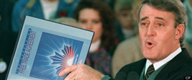  Was free trade in our best interests?

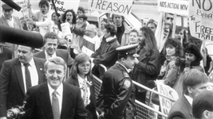Protestors opposing the FTA during the 1988 election. | Canada held a Federal election in November 1988. The main issue during the election campaign was the Free Trade Agreement. Canadians were divided. Many supported the agreement hoping for economic benefits. Others were not supportive. During an election debate, Liberal leader John Turner accused Mulroney of turning Canada into a “colony of the United States.”

Which image do you think is more accurate?
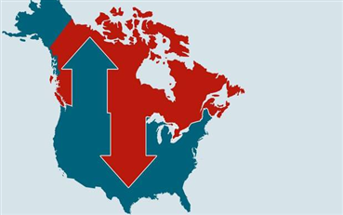  What kind of relationship does this image convey about the Free Trade Agreement? | 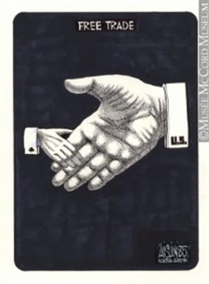  What kind of relationship does this image convey about the Free Trade Agreement?

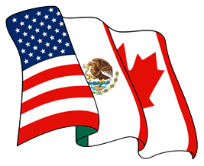Coat of Arms of NAFTA | Five years after the Free Trade agreement was signed, Mexico joined and it was renamed the North American Free Trade Agreement. There are three major highlights of NAFTA. They include:  - No Tariffs (taxes on imported manufactured goods and services are eliminated);  - Dispute Panel (a panel will resolve trade disputes but members can ignore their decisions);  - Shared Resources (access to natural gas, water, or other natural resources cannot be denied once it becomes a tradeable good).
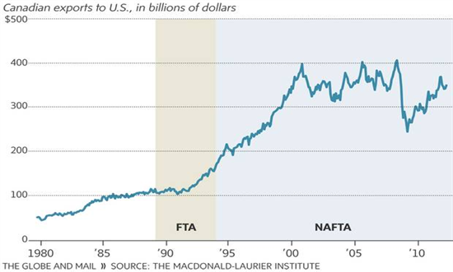

Which agreement had the largest impact on Canada?

