French – English Relations
Read the short Canadian story: Hockey Sweater.
This story reveals the love of culture, language, the Catholic Church, the hockey rink, and the feeling of being in a close knit community of shared values. It also shows the divisions of power and wealth between the French and English, which fueled the French separatist movement (Quebec leaving Canada). The Hockey Sweater revealed to Canadians that although there were many values shared by the French and English people, there was also cause for concern because of the divisions.

How did Hockey lead to a French and English divide?
Maurice “Rocket” Richard was a Canadian legend who played for the Montreal Canadiens. The suspension of Maurice "Rocket" Richard angered the fans of the Canadiens. They responded by rioting on the streets and egging NHL President Clarence Campbell.
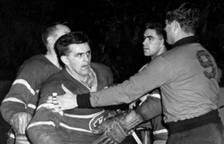Many French felt the suspension of Maurice Richard was unjustified. | When I got home, I listened to the riot on the radio...I felt badly. Once I felt like going downtown and telling the people over a loudspeaker to stop their nonsense. But it wouldn't have done any good. They would have carried me around on their shoulders......I'm not a politician, I'm just a hockey player...  Maurice "Rocket" Richard, 1955
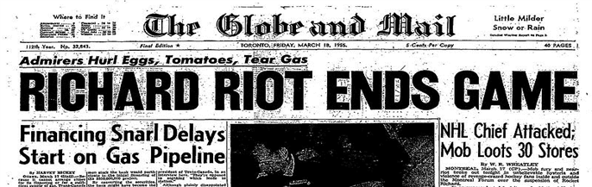
The Forum was home to the Montreal Canadiens; this riot was known as "the most destructive and frenzied riot in the history of Canadian sport."
In response to many concerns of the French living in Quebec, Jean Lesage (premier of the Liberals) set forward to make sweeping changes in Quebec known as the Quiet Revolution.  Under the slogan "Maîtres Chez Nous" (masters in our own house), the government set out to strengthen the province economically, politically, socially by:  - Setting up their own pension plans;  - Investing in Hydro Quebec;  - Setting up programs to support French language and culture;  - Modernizing the education system;  - Joining Medicare;  - And lowering the voting age from 21 to 18. | 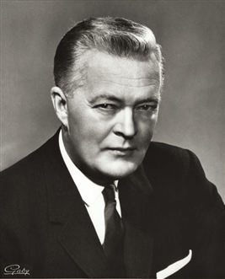Jean Lesage, 1960

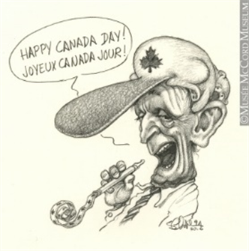  This cartoon is a caricature of Quebecois Prime Minister Jean Chretien (1993-2003). Is it necessary for our prime ministers to be bilingual? | In 1969, the Official Languages Act secured that Canada would have two official languages: French and English and that all Canadians will have access to services providing by all federal institutions in either language

Terrorism in Canada?
In April 1963, things turned violent in Quebec. The FLQ, The Front de Liberation du Quebec, began a campaign of terror to draw attention to their desire for an independent and socialist Quebec. Between 1963 and 1970, they were responsible for more than 200 bombings.
On October 5, 1970, the FLQ kidnapped James Cross who was the British trade commissioner starting the October Crisis.
A few days after the War Measures Act was declared, Pierre Laporte was murdered. His body was found in the trunk of car on October 18th.  The War Measures Act was in effect for two and a half weeks, and over 450 people were arrested although most had nothing to do with the FLQ.  Behind the scenes, police negotiated with the FLQ. James Cross was released by the kidnappers and five members of the FLQ as well as some of their family members were flown to Cuba – a country that sympathized with their revolutionary beliefs. | 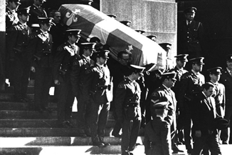A Consequence of the War Measures Act

What was the legacy of the October Crisis?
Watch a review of the crisis 20 years later from the CBC Archives to discover the legacy of the October Crisis. As time passes, historians have the opportunity to gather evidence and examine the event from a variety of perspectives giving them a more complete story. Comparing reports at the time of the event gives you an understanding of how the event's significance has changed over time. What new details are revealed? Have the views of the event changed? Have the perspectives changed? What were the long term consequences?
In 1976, Quebec elected a party dedicated to separating from Canada. Rene Levesque became known for his role in the sovereignty movement.
This government passed Bill 101, known as the Charter of the French Language, requiring all provincial government agencies to use French only. All advertising and signs were to be in French, and large businesses were required to use French in the workplace.
As a result, some companies left Quebec, as did many Anglophones.
Is this a protection of rights or an infringement of rights?

In hopes of independence, the PQ's call for a referendum in 1980 which divided the province. If the result was yes it would mean an independent Quebec in terms of laws, policies, and taxes but would still remain connected to the Canadian economy so that goods and people could move easily between Quebec and the rest of the country.
Results: 60% rejected this referendum
Quebec would remain a part of Canada

