Portable Pink Crazy Fit Bio Body Shaker Exercise Machine
- 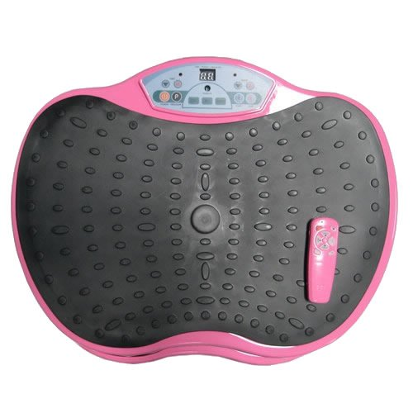
- About the Product
- Adjustable speed settings avalaible.
- Stable running with direct current dynamo motor.
- No Assembly required. Comes with Remote Control.
- Capacity up to 250lbs.
- Convenient to use at home and office due to its portability.

Product Description
Burns Fat and tones and tightens Skin - Increased fat burning because the metabolism increases by training. The vibrations reshape the body in the hip, waist and abdomen. Increases Human Growth Hormone output by up to 361%. Decreases cellulite and boosts your body's natural collagen production: The massage exercises loosen the agglutinations and results in better mobility of the tissue layers. The image of the skin will also improve, because cellulite are broken down and the connective tissue is enhanced therefore it would boost your body's natural collagen production for improved skin texture. Increase your muscle strength up to 50% in as little as three weeks: During the training almost 100% of the muscle fibers are utilized. Improves blood circulation and lymphatic drainage and metabolism: During training, the muscles pump blood into the smallest capillaries up to 50 times per second. This allows the cells to receive fuel more rapidly and causes waste products to be disposed of much faster. Also by enhancing your local circulation it builds a stronger immunity system. Builds Bone Density and fights osteoporosis and reduces your back and joint pains. Decreases blood Pressure Decrease your recovery time after workouts. Dramatically increase your flexibility: Due to better blood flow, heating of the muscles and the tendon stretching reflex, the body becomes much more supple and relaxed. Improved sense of balance and coordination: The receptors in the entire body are stimulated at the same time, which leads to improved coordination of the relating muscles at the same time the sense of balance are trained. Elevates stress: Causing better mood and sense of well being. It helps your relax with its vibration and it also can help you fight insomnia.
Top of Form

Suzanne Somers ThighMaster Gold
$29.99

Still the Best for Rock Hard Thighs!
Value Alert: For just $10 more, you can also get the ThighMaster LBX (ButtMaster) in the incredible ThighMaster Toning System!

The Famous Leg Workout At-Home Device That Tones, Shapes, and Firms Your Inner Thighs

It's my famous ThighMaster! This little wonder is still the best way to tone, shape and firm your inner thighs with just a few squeezes a day.
- Squeeze your way to firmer thighs
- Easy to use - work out and watch TV
- Totally portable for home or office
- 100% satisfaction guaranteed
Should you use the Suzanne Somers Thighmaster?
A blast from the past is still alive and doing well today.
She showed millions how to get thin thighs back in the 80′s and 90′s and it can still do the same for you today. My wife said sure the ThighMaster works. She pulled out a couple of things she uses to do the same thing the ThighMaster does. One was a ball she puts between her knees and squeezes and the other was a round ring that she squeezes in the same way. I think she is looking forward to the new ThighMaster I have ordered. Actually I have ordered 10 of them and plan to sell them on this website and maybe give them as a Christmas present. Well Christmas has come and gone and I have made another website called the Suzanne Somers Thighmaster on Tumblr where you can order from an online store. You can also purchase some of her books on a healthy lifestyle and natural living.
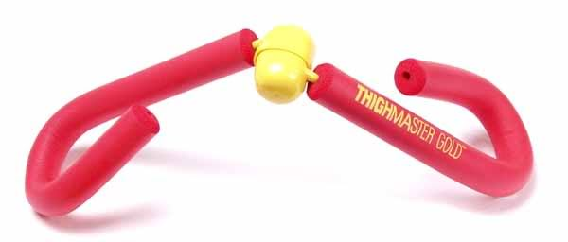

Suzanne Somers Thighmaster is a 90’s made product that has stood the test of time and proven that it offers results. There have been thousands of people who have used the Thighmaster in the past 20 years, many of whom would never consider using any other product to help them attain their fitness goals. The Thighmaster is so easy-to-use, as well as lightweight and compact, making it a product that always exceeds your expectations.
Suzanne Somers Thighmaster
Benefits of Suzanne Somers Thighmaster
The benefits found with the Thighmaster are numerous. Take a look at the things you can expect when using the exercise device.
- There is no assembly required. Simply take it out of the box and you are ready to begin.
- Thighmaster offers the ability to tone your thighs, but it does not stop with just one area. You can use the Thighmaster on many other areas of the body, ensuring that you are toned all over.
- It is so easy-to-use it is perfect for those who have just begun working out.
- You will never have to visit the gym again!
- Costs of the Thighmaster are sure to put a smile on your face. It is affordable even for individuals on a tight budget.
These are only a few of the awesome benefits that you will find when using the Thighmaster. When used for at least 20 minutes three to four times per week, Thighmaster can show you the results that you are looking for. There is no better way to get a toned, beautiful body, just like the beautiful Somers.

Why should you use Thighmaster
It is easy to gain weight- and fat. When you use Thighmaster all of that weight will slide right off while helping you attain a gorgeous body. Because the device is compact and portable it can be used anytime, anyplace, leaving you without excuse to workout. But, as fun as it is to squeeze and tighten, you will want to use it frequently while on your weight loss diets.
Thighmaster makes it easy to quickly lose weight. In just a few short weeks you can see a dramatic change in the way that your body looks and feels. With extended use those results only increase. Before you know it you will be a new person; a person that you love once again.
There are many products out there claiming to help you tone muscles and lose excess fat, but many of those are simply that- claims. The Suzanne Somers Thighmaster has proven results, and 20 years worth of them.
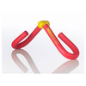http://www.suzannesomers.com/products/suzanne-somers-thighmaster-gold - tab-4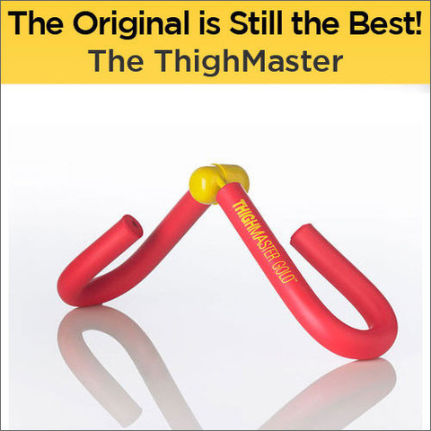Bottom of Form

