Image |  | Value | Common name
Obverse | Reverse
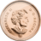 | 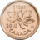 | 1¢ | Penny
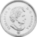 |  | 5¢ | Nickel
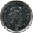 | 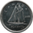 | 10¢ | Dime
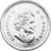 | 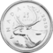 | 25¢ | Quarter
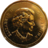 | 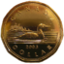 | $1 | Loonie
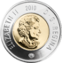 | 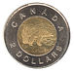 | $2 | Toonie

